**Step 1:**

create python anywhere account

**Step 2:** create virtual environment

**Step 3:** git clone from git up the project

**Step 4:**

pip install django

pip install -r requirements.txt

pip install mysqlclient

python manage.py runserver

**Step 3:** update database details

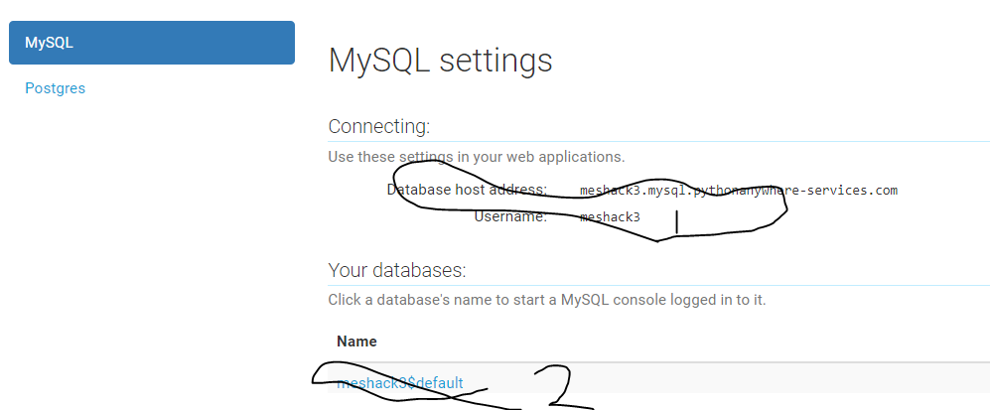

**Step 4:**

-ls

-pwd

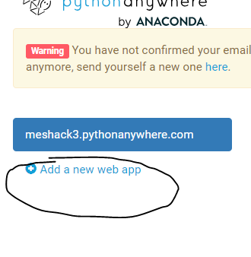

**Step 5:**

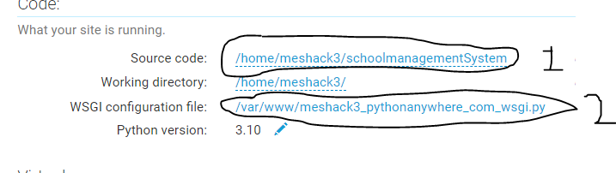

**Step 6:**

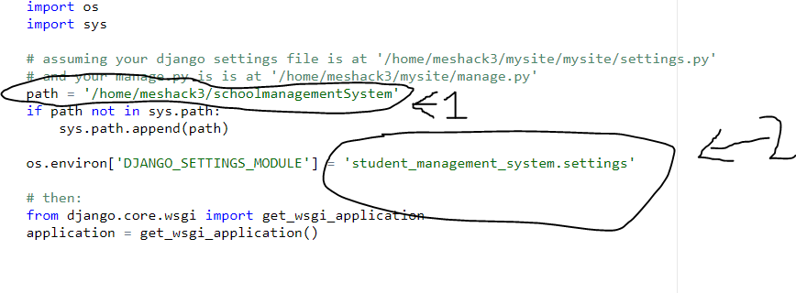

**Step 7:**

**successful**

**Run your web project**